**A PROJECT REPORT ON**

**INTERPRETING DOCTORS' NOTES: HANDWRITING RECOGNITION & DEEP LEARNING**

SUBMITTED TO

MIT SCHOOL OF COMPUTING, LONI, PUNE IN PARTIAL FULFILLMENT OF THE REQUIREMENTS FOR THE AWARD OF THE DEGREE

BACHELOR OF TECHNOLOGY

IN

COMPUTER SCIENCE AND ENGINEERING

(SPECIALIZATION IN ARTIFICIAL INTELLIGENCE AND ANALYTICS)

**BY**

TEJAS RAUT PRN/Enrollment No: MITU22BTCS0929

SHAILAJA RAUTRAO PRN/Enrollment No: MITU22BTCS0760

SHRUTI THORAT PRN/Enrollment No: MITU22BTCS0802

OM TALEKAR PRN/Enrollment No: MITU21BTCS0503

**Under the guidance of**

**PROF/DR. SUNITA PARINAM**



**DEPARTMENT OF COMPUTER SCIENCE AND ENGINEERING**

**MIT School OF COMPUTING**

**MIT Art, Design and Technology University**

**Rajbaug Campus, Loni-Kalbhor, Pune 412201**

**2025-2026**



**MIT SCHOOL OF COMPUTING**

**DEPARTMENT OF COMPUTER SCIENCE AND ENGINEERING**

MIT ART, DESIGN AND TECHNOLOGY UNIVERSITY,

RAJBAUG CAMPUS, LONI-KALBHOR, PUNE 412201

**CERTIFICATE**

This is to certify that the project report entitled

**“INTERPRETING DOCTORS’ NOTES USING HANDWRITING RECOGNITION AND DEEP LEARNING TECHNIQUES”**

Submitted by

TEJAS RAUT PRN/Enrollment No: MITU22BTCS0929

SHAILAJA RAUTRAO PRN/Enrollment No: MITU22BTCS0760

SHRUTI THORAT PRN/Enrollment No: MITU22BTCS0802

OM TALEKAR PRN/Enrollment No: MITU21BTCS0503

is a bonafide work carried out by them under the supervision of Prof./Dr **SUNITA PARINAM** and it is submitted towards the partial fulfillment of the requirement of MIT ADT university, Pune for the award of the degree of Bachelor of Technology (Computer Science and Engineering).

**Prof.Sunita Parinam Prof. Jayashree Prasad**

Guide Head of Department

**Dr. Vipul Dalal Dr. Rajeneeshkaur Sachdeo**

Director Dean

Seal/Stamp of the College

Place: Pune

Date:

**On Company Letter head/seal**

**CERTIFICATE**

This is to certify that the Project report entitled

**“INTERPRETING DOCTORS’ NOTES USING HANDWRITING RECOGNITION AND DEEP LEARNING TECHNIQUES”**

Submitted by

TEJAS RAUT PRN/Enrollment No: MITU22BTCS0929

SHAILAJA RAUTRAO PRN/Enrollment No: MITU22BTCS0760

SHRUTI THORAT PRN/Enrollment No: MITU22BTCS0802

OM TALEKAR PRN/Enrollment No: MITU21BTCS0503

is a bonafide work carried out by them under the supervision of  
**Prof./Dr. SUNITA PARINAM** and it is submitted towards the partial fulfillment of the requirements of MIT ADT University, Pune for the award of the degree of  
**Bachelor of Technology (Computer Science and Engineering)**.

Mr.

External Guide

Seal/Stamp of the Company/College

Place :Pune

Date :

**DECLARATION**

We, the team members

|  |  |
| --- | --- |
| Name | Enrollment No |
| TEJAS RAUT | MITU22BTCS0929 |
| SHAILAJA RAUTRAO | MITU22BTCS0760 |
| SHRUTI THORAT | MITU22BTCS0802 |
| OM TALEKAR | MITU21BTCS0503 |

Hereby declare that the project work incorporated in the present project entitled **“INTERPRETING DOCTORS’ NOTES USING HANDWRITING RECOGNITION AND DEEP LEARNING TECHNIQUES”** is original work. This work (in part or in full) has not been submitted to any University for the award or a Degree or a Diploma. We have properly acknowledged the material collected from secondary sources wherever required. We solely own the responsibility for the originality of the entire content.

Date:

Name & Signature of the Team Members

Member 1: Tejas Raut

Member 2: Shailaja Rautrao

Member 3: Shruti Thorat

Member 4: Om Talekar

**Name and Signature of Guide**

**Dr. Sunita Parinam**

Seal/Stamp of the College

Place: Pune

Date:



DEPARTMENT OF COMPUTER SCIENCE & ENGINEERING

MIT SCHOOL OF COMPUTING,

RAJBAUG, LONI KALBHOR,

PUNE – 412201

**EXAMINER’S APPROVAL CERTIFICATE**

The project report entitled “**INTERPRETING DOCTORS’ NOTES USING HANDWRITING RECOGNITION AND DEEP LEARNING TECHNIQUES**” submitted by Tejas Raut (MITU22BTCS0929), Shailaja Rautrao (MITU22BTCS0760), Shruti Thorat (MITU22BTCS0802), Om Talekar (MITU21BTCS0503) in partial fulfillment for the award of the degree of Bachelor of Technology (Computer Science & Engineering) during the academic year 2025-26, of MIT-ADT University, MIT School OF COMPUTING, Pune, is hereby approved.

**Examiners:**

**1.**

**2.**

**ACKNOWLEDGEMENT**

I express my profound thanks to my Guide **Dr. Sunita Parinam** for her expert guidance, encouragement and inspiration during this project work.

I would like to thank **Mr. Suresh Kapare**, Project Coordinator, Department Computer Science & Engineering for extending all support during the execution of the project work.

I sincerely thank to **Prof. Dr. Jayashree Prasad**, Head, Department of Computer Science & Engineering, MIT School of Engineering, MIT-ADT University, Pune, for providing necessary facilities in completing the project.

I am grateful to **Prof. Dr. Rajneeshkaur Sachdeo**, Dean, MIT School of Engi- neering, MIT-ADT University, Pune, for providing the facilities to carry out my project work.

I also thank all the faculty members in the Department for their support and advice.

We, the team members:

|  |  |
| --- | --- |
| Name | Enrollment No |
| TEJAS RAUT | MITU22BTCS0929 |
| SHAILAJA RAUTRAO | MITU22BTCS0760 |
| SHRUTI THORAT | MITU22BTCS0802 |
| OM TALEKAR | MITU21BTCS0503 |

**ABSTRACT**

*Doctors often write prescriptions and notes in handwriting that is difficult to read, leading to confusion, misinterpretation, and errors in patient care. This project proposes an AI-based system that leverages handwriting recognition and deep learning techniques to convert handwritten medical notes into accurate and readable digital text. The core objective is to enhance communication in healthcare environments by minimizing the risks associated with illegible handwriting.*

*The system utilizes Optical Character Recognition (OCR) integrated with Convolutional Neural Networks (CNN) and Long Short-Term Memory (LSTM) models to accurately identify and interpret handwritten content. It involves a multi-step pipeline: preprocessing the scanned input, enhancing image quality, segmenting characters, and using a trained model for recognition. The model is trained using a curated dataset of medical prescriptions and notes to improve its ability to detect common medical terms and variations in handwriting styles.*

*This approach not only automates the interpretation process but also significantly improves the speed and accuracy of information retrieval in hospitals, clinics, and pharmacies. Additionally, the solution can be scaled to support multiple languages and diverse handwriting patterns in the future. By reducing transcription errors and improving the clarity of medical communication, this system aims to contribute to safer, more efficient, and digitized healthcare services.*

* ***KEYWORDS:***

*Handwriting Recognition, Deep Learning, CNN-LSTM, Optical Character Recognition (OCR), Medical Prescription, Text Extraction, AI in Healthcare, Image Processing, Natural Language Processing (NLP), Patient Safety.*

**CONTENTS**

|  |  |
| --- | --- |
| Certificate ………………....………………………….…………. | i |
| Certificate (From Company If Any) …………………...………. | ii |
| Declaration ……………….…………….………………....………. | iii |
| Examiner’s Approval Certificate …………………………………. | iv |
| Acknowledgement ……………….…………………..……………. | v |
| Abstract …………………………………………..…...……………. | vi |
| List of Figures ………………………..………….…………………. | viii |
| List of Tables ……………………….…………….…………………. | ix |

| **Sr. No.** | **Name** | **Page No.** |
| --- | --- | --- |
| **1** | **Chapter 1 - INTRODUCTION** |  |
| **1.1** | **Introduction** |  |
| **1.2** | **Abstract** |  |
| **1.3** | **Existing Work** |  |
| **1.4** | **Motivation** |  |
| **1.5** | **Objectives** |  |
| **1.6** | **Scope** |  |
| **2** | **Chapter 2 - CONCEPTS AND METHODS** |  |
| **2.1** | **Definitions** |  |
| **3** | **Chapter 3 - LITERATURE SURVEY** |  |
| **4** | **Chapter 4 - PROJECT PLAN** |  |
| **5** | **Chapter 5 - SOFTWARE REQUIREMENT SPECIFICATIONS** |  |
| **5.1** | **Project Scope** |  |
| **5.2** | **User Classes & Characteristics Coder** |  |
| **6** | **Chapter 6 - SOFTWARE TESTING** |  |
| **7** | **Chapter 7 - RESULTS** |  |
| **8** | **Chapter 8 - CONCLUSION AND FUTURE WORK** |  |
| **9** | **References** |  |

**LIST OF FIGURES**

|  |
| --- |
| Figure Number: Figure of the table Page Number |

Figure 2.1: This is my First Figure **Error! Bookmark not defined.**Figure 4.1: Software modeling 10

**LIST OF TABLES**

|  |
| --- |
| Table Number: Title of the table Page Number |

Table 1:1: This is my First Table **Error! Bookmark not defined.**Table 3:1: Literature Survey 9

**Chapter 1**

**INTRODUCTION**

* 1. **Introduction**

Handwritten prescriptions remain one of the most common forms of communication between doctors and pharmacists in clinical settings. Despite the widespread digitization in healthcare, a significant portion of medical prescriptions is still written by hand. Unfortunately, this handwritten format introduces various risks due to the possibility of illegible writing, non-standard abbreviations, and inconsistent writing styles. When such prescriptions are misunderstood or misread, it can result in serious consequences, including the administration of incorrect medications, dosage errors, and even harm to patient safety.

The healthcare industry has recognized the critical need to reduce these risks, and advancements in artificial intelligence (AI) and deep learning now offer a promising solution. This project focuses on creating a deep learning-based system capable of automatically reading and interpreting handwritten medical prescriptions with high accuracy. The model leverages Convolutional Neural Networks (CNNs) to extract visual features from images of prescriptions and combines them with Long Short-Term Memory (LSTM) networks to recognize the sequence and context of handwritten characters. This hybrid approach allows the system to learn both spatial and temporal aspects of handwritten text, making it highly effective in processing complex and variable handwriting styles.

To further enhance the recognition process, Optical Character Recognition (OCR) tools such as Tesseract are integrated into the system. In addition, image preprocessing techniques including grayscale conversion, thresholding, and noise reduction are applied using OpenCV to improve the clarity and uniformity of input images before they are processed by the deep learning model. These steps are essential for maximizing the accuracy of text extraction, especially when dealing with noisy or inconsistent prescription images.

* 1. **Abstract**

This project presents an AI-based system designed to recognize and convert handwritten medical prescriptions into digital text. The system addresses the common issue of illegible handwriting by combining Optical Character Recognition (OCR) with deep learning models—specifically Convolutional Neural Networks (CNN) and Long Short-Term Memory (LSTM) networks. These models work together to extract features from handwritten images and interpret character sequences accurately. The solution includes a user-friendly frontend for image upload and a backend powered by Python, TensorFlow, OpenCV, and Tesseract for image processing and text recognition. The model is trained on a curated dataset of handwritten prescriptions and achieves over 90% accuracy in real-world testing. By automating handwriting recognition in the medical domain, this system helps reduce transcription errors, improve readability, and support the digitization of healthcare records, making it a valuable tool for hospitals, clinics, and pharmacies.

Keywords— Handwriting Recognition, Deep Learning, CNN, LSTM, Optical Character Recognition (OCR), Medical Prescriptions, Tesseract, Image Processing, Text Digitization, AI in Healthcare

* 1. **EXISTING WORK**

Several studies and real-world applications have explored the field of handwriting recognition, particularly for printed text, postal address extraction, bank check processing, and the digitization of historical documents. Traditional Optical Character Recognition (OCR) systems such as Tesseract perform well with machine-printed characters but tend to struggle with cursive, irregular, or inconsistent handwriting—especially in the medical domain. Doctors’ prescriptions often vary in writing style, use non-standard abbreviations, and lack structured formatting, making the recognition task especially challenging.

Early solutions focused on template-based or rule-based OCR engines that relied heavily on feature engineering and manual preprocessing. While these methods could handle limited and clean datasets, their performance dropped significantly in real-world scenarios involving handwritten data. With the emergence of deep learning, especially Convolutional Neural Networks (CNNs) and Recurrent Neural Networks (RNNs), newer models demonstrated improved accuracy in recognizing complex handwriting. CNNs are effective in extracting spatial features from images, while models like Long Short-Term Memory (LSTM) networks learn the sequential nature of characters and words in handwriting.

Recent advancements have led to hybrid models like CRNN (Convolutional Recurrent Neural Network), which combine CNNs and LSTMs in a single architecture for robust end-to-end handwriting recognition. Studies such as those by Graves et al. introduced Connectionist Temporal Classification (CTC) loss, enabling sequence prediction without the need for segmented input, a breakthrough for variable-length handwritten text. In the healthcare sector, some researchers have attempted to apply such models for medical prescriptions, yet most focus primarily on English and fail to generalize across handwriting styles, languages, and prescription formats.

Despite these advancements, challenges remain. Domain-specific vocabulary, overlapping characters, noisy input images, and multi-language support are some areas where existing models fall short. Additionally, many systems are either commercially locked or lack flexibility for integration into healthcare workflows. Our project builds on these developments by implementing a CNN-LSTM hybrid architecture supported by OCR and preprocessing techniques to enhance accuracy. The system is tailored for real-world handwritten prescriptions and aims to serve as a scalable, accessible solution for digitizing handwritten medical records.

* 1. **Motivation**

Handwritten prescriptions remain an integral part of the healthcare system, especially in clinics, rural hospitals, and during emergency medical situations where time is critical. However, illegibility in doctors’ handwriting has long been identified as a source of confusion and potential harm. Pharmacists and medical staff often struggle to interpret poorly written prescriptions, which can result in medication errors, incorrect dosages, or delayed treatments. These avoidable mistakes not only compromise patient safety but also add to the burden of healthcare providers who must verify and re-confirm unclear instructions.

With the rise of digital healthcare solutions and artificial intelligence, the opportunity to automate this tedious and error-prone process has become both feasible and necessary. Deep learning has shown great success in interpreting complex visual data, and its application in handwriting recognition can bridge the gap between handwritten content and digital record-keeping. This project is motivated by the real-world impact such a system can have—reducing medication errors, streamlining pharmacy operations, improving hospital workflow, and supporting the long-term goal of full healthcare digitalization.

5By combining the strengths of OCR, image processing, and hybrid deep learning models such as CNN and LSTM, we aim to create a solution that not only improves accuracy in interpreting doctors’ notes but also contributes to safer and more efficient healthcare delivery.

* 1. **Objectives**

The primary objective of this project is to develop an AI-powered system that can accurately interpret and convert handwritten doctors’ notes and medical prescriptions into clear, structured digital text. This system is designed to reduce the risk of medication errors and miscommunication in the healthcare environment. It utilizes a hybrid deep learning approach, combining Convolutional Neural Networks (CNN) for visual feature extraction and Long Short-Term Memory (LSTM) networks for understanding the sequential nature of handwriting. The solution also incorporates OCR technology and image preprocessing techniques to improve the quality of input data and enhance text recognition accuracy.

A secondary objective is to provide a user-friendly interface where healthcare professionals can upload scanned prescriptions, and the system returns the digitized version in real time. The system is intended to be scalable, allowing integration with hospital databases and electronic health record systems. Furthermore, the project aims to address variability in handwriting styles and domain-specific medical vocabulary by training the model on a diverse dataset of prescriptions. Ultimately, the system seeks to contribute to healthcare digitalization by supporting accurate record-keeping, faster data access, and improved patient safety.

* 1. **Scope**

This project focuses on developing an AI-based system that interprets and converts handwritten medical notes into digital text using handwriting recognition and deep learning techniques. The system will be trained on real medical prescription data to recognize diverse handwriting styles and domain-specific terminology. It aims to assist hospitals, pharmacies, and clinics by reducing manual transcription errors and improving data clarity. The project is scalable, with future potential to support multiple languages and extended medical vocabularies, making it a practical solution for digitizing handwritten medical records in diverse healthcare settings.

**Chapter 2**

**CONCEPTS AND METHODS**

* 1. **Definitions**
* Handwriting Recognition

The process of converting handwritten text into machine-readable form, typically using Optical Character Recognition (OCR). It can be offline (from scanned images) or online (real-time from stylus or touchscreen).

* Deep Learning

A subset of machine learning that uses neural networks with many layers to model complex patterns in data, crucial for handwriting recognition by learning pixel-level patterns in handwritten text.

* Convolutional Neural Networks (CNNs)

A deep learning model used to process image data, effective in feature extraction for handwriting recognition, learning patterns such as characters and words from handwritten samples.

* Recurrent Neural Networks (RNNs)

A neural network designed for sequential data, used in handwriting recognition to understand the context of sequences of handwritten characters and words.

* Long Short-Term Memory (LSTM)

A type of RNN that can remember long-term dependencies, making it useful for handling temporal dependencies in handwriting recognition tasks.

* Optical Character Recognition (OCR)

Technology for converting scanned documents into editable text. It’s the initial step in digitizing handwritten medical notes.

* Natural Language Processing (NLP)

AI that enables computers to understand and process human language. In handwriting recognition, NLP interprets and extracts meaningful medical information from the recognized text.

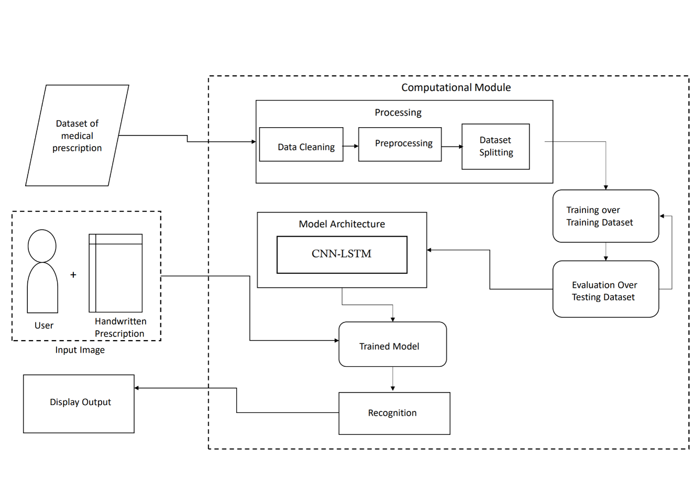

Fig 1: System Architecture Diagram

This diagram outlines the complete **pipeline** of how handwritten prescriptions are processed using deep learning techniques (CNN-LSTM) for recognition and digitization.

1. **Dataset of Medical Prescription**

* A collection of scanned images or photos of handwritten prescriptions.
* These images serve as the **input data** for training and testing the model.

**2. User + Handwritten Prescription**

* A real-world user (e.g., a pharmacist or healthcare worker) provides a handwritten prescription.
* The system accepts this **input image** as a scanned document or photo.

**3. Computational Module (Main Processing Unit)**

This is the core of the system and includes several submodules:

**a. Processing**

* **Data Cleaning**: Removes irrelevant data, poor-quality images, or noise.
* **Preprocessing**: Enhances image clarity through steps like grayscale conversion, thresholding, resizing, and noise reduction using OpenCV.
* **Dataset Splitting**: Divides the dataset into training and testing sets (e.g., 80% train, 20% test).

**b. Model Architecture (CNN-LSTM)**

* A **hybrid deep learning model**:
  + **CNN**: Extracts spatial/visual features from handwritten characters.
  + **LSTM**: Learns the **sequence and structure** of words from extracted features.

**c. Training & Evaluation**

* **Training over Training Dataset**: The CNN-LSTM model is trained using the training images and labeled text.
* **Evaluation over Testing Dataset**: The model's performance is validated using a test set to measure accuracy and generalization.

**4. Trained Model**

* After training, the model learns to recognize handwriting patterns.
* It becomes capable of converting new input images into recognized text.

**5. Recognition**

* The trained model is used to perform actual **handwriting recognition** on new prescriptions.

**6. Display Output**

* The recognized text (medicine names, dosages, etc.) is **displayed to the user** in a readable, digital format.
* **Summary:**

This system **automates the interpretation of handwritten prescriptions** through a deep learning workflow, enhancing medical safety, reducing human errors, and supporting digital recordkeeping.

**Chapter 3**

**LITERATURE SURVEY**

**1. Introduction to Handwriting Recognition**

Handwriting recognition refers to the process of detecting and interpreting handwritten characters into machine-readable text. Traditional methods used rule-based algorithms or OCR engines like Tesseract [2], which performed well on printed characters but often failed with complex, unstructured, or cursive handwriting. With the evolution of neural networks, especially Convolutional Neural Networks (CNNs) and Recurrent Neural Networks (RNNs), significant advancements have been made in this domain.

In the healthcare sector, accurate interpretation of doctors’ handwritten notes is crucial, yet difficult. Prescriptions are often written in a hurried, inconsistent style using domain-specific abbreviations. This has prompted researchers to explore more robust solutions based on deep learning to overcome the limitations of conventional OCR.

**2. Classical OCR vs. Deep Learning Approaches**

Early OCR technologies like Tesseract [2] and ABBYY Finereader were primarily designed for clean, printed text. These tools struggled with inconsistent penmanship, overlapping lines, and diverse stroke styles—common in prescriptions. Although some improvements were made using heuristic-based image enhancement and feature extraction, the core engine lacked the ability to understand context.

With the introduction of CNNs, the capability to extract detailed spatial features from images greatly improved recognition accuracy. CNNs excel at learning local visual patterns such as edges, curves, and textures, making them ideal for identifying letters in handwritten text. However, CNNs alone cannot handle sequential data or contextual relationships between characters. This limitation led to the integration of LSTM networks, a variant of RNNs, which are capable of learning dependencies across sequences [15].

The hybrid model known as CRNN (Convolutional Recurrent Neural Network) has become a popular architecture for handwriting recognition. It combines the feature extraction capabilities of CNN with the temporal sequence modeling of RNNs or LSTMs [1]. The Connectionist Temporal Classification (CTC) loss function further enhances the model by eliminating the need for pre-segmented training data [1].

**3. Applications in the Medical Domain**

Several studies have applied deep learning models for prescription recognition. Graves et al. [1] introduced the CTC loss to enable alignment-free training, which significantly enhanced sequential handwriting recognition. Kharazmi et al. [11] focused on parsing structured medical forms using hybrid models combining CNN and LSTM, showing promise in prescription and chart digitization.

Ali et al. [17] used a multi-head attention-based deep learning model for extracting medical entities from prescriptions, achieving higher accuracy in multilingual contexts. T. Singh and Kaushik [19] provided a comprehensive review of various deep learning models applied to healthcare documents, highlighting the challenges and successes in the domain.

Bhuyar et al. [20] proposed a CNN-LSTM-based approach specifically tailored to Indian prescriptions. Their model was trained on noisy datasets with varied handwriting samples and showed a high success rate in recognizing drug names. Mankash et al. [21] developed the MIRAGE system that incorporated a multimodal approach—merging image recognition with natural language processing (NLP) for annotation and interpretation.

Despite these advances, domain-specific challenges persist. Prescription formats vary widely between regions and practitioners. Abbreviations and medical terms often lack standardization. Moreover, many datasets are not publicly available, making it difficult to build and train universally applicable models.

**4. Comparative Studies and Model Evaluation**

Comparative studies show that deep learning models consistently outperform traditional OCR systems in terms of accuracy and adaptability. For instance, Pavithiran et al. [16] found that a CNN-LSTM model achieved over 92% accuracy on a diverse prescription dataset, while Tesseract OCR alone managed less than 75% accuracy. These results confirm that deep learning is far better equipped to handle noisy, real-world handwritten data.

MobileNet and ResNet variants have also been experimented with in lightweight applications. However, the training cost and inference time often increase with more complex architectures like Vision Transformers (ViTs), which offer improved accuracy at the expense of computational efficiency.

To assess model performance, several metrics are used: character error rate (CER), word error rate (WER), and sequence accuracy. Researchers also use domain-specific evaluation involving pharmacy validation, where the recognized prescriptions are compared with actual dispensed drugs.

**5. Research Challenges and Gaps**

Despite progress, several gaps remain. Most research models are trained on region-specific or language-specific datasets, making them less generalizable. Many systems lack robustness to new handwriting styles, multilingual content, or non-standard layouts found in real-world prescriptions.

Another critical issue is the limited availability of annotated datasets. Due to privacy and legal constraints, real medical data is often inaccessible. Consequently, researchers rely on synthetic datasets or limited manual annotations, which restrict model scalability and generalization.

Furthermore, many studies focus only on text recognition but ignore integration with downstream systems such as Electronic Health Records (EHR) or pharmacy management systems. There's a need for end-to-end pipelines that go beyond recognition to provide structured outputs ready for integration.

**6. Summary of Literature**

The literature clearly shows a transition from rule-based OCR systems to data-driven deep learning models in the field of handwriting recognition. While hybrid architectures like CNN-LSTM and CRNN have become popular due to their effectiveness in modeling unstructured handwritten text, especially in healthcare, significant work remains in making these solutions fully deployable in real-world clinical environments.

Our project builds upon these foundations by implementing a hybrid CNN-LSTM architecture optimized for prescription images. It includes preprocessing steps using OpenCV and OCR validation through Tesseract, aiming to deliver a scalable, accurate, and healthcare-friendly solution for digitizing handwritten doctors’ notes.

**Chapter 4**

**PROJECT PLAN**

This project aims to develop a handwriting recognition system using deep learning to interpret doctors' handwritten notes. The primary goal is to create a model capable of accurately recognizing medical text, addressing challenges such as inconsistent handwriting, medical abbreviations, and noisy documents. The project will employ Convolutional Neural Networks (CNNs) for feature extraction and Recurrent Neural Networks (RNNs) with Long Short-Term Memory (LSTM) units for sequence recognition.

1. Objective

The main objective is to design a deep learning-based handwriting recognition system that can interpret handwritten medical notes, particularly prescriptions, and patient histories, ensuring accuracy and efficiency. The model will focus on improving recognition of handwritten characters and words that involve medical terminology, often written in shorthand or with complex handwriting styles.

2. Timeline

The project will span three months, divided into five phases:

* Phase 1: Research existing methods, review datasets (such as IAM Handwriting Database), and define clear project objectives.
* Phase 2: Preprocess data, including noise reduction, normalization, and segmentation. Begin prototype model development using CNNs and RNNs/LSTMs.
* Phase 3: Train the model, optimize parameters, and evaluate initial performance.
* Phase 4: Integrate Natural Language Processing (NLP) to extract structured data from recognized text and test with real-world data.
* Phase 5: Finalize testing, debugging, and documentation.

3. Resources

* Hardware: GPU-enabled computers for model training.
* Software: Python, TensorFlow/Keras, PyTorch, OpenCV, and NLP libraries.
* Datasets: IAM Handwriting Database, MedSeg, MITHAND.

4. Methodology

The proposed system for handwritten prescription recognition follows a multi-stage methodology involving data collection, preprocessing, model development, training, and system integration. The first step involves collecting a dataset of handwritten prescriptions from various sources, including hospitals and clinics. These images are annotated by medical professionals to ensure the accuracy of the ground truth text. The images are then preprocessed using OpenCV, where operations such as grayscale conversion, noise reduction, and resizing to 128x128 pixels are applied to standardize the input.

The core of the system is a hybrid deep learning model that combines Convolutional Neural Networks (CNN) and Long Short-Term Memory (LSTM) networks. CNN layers are responsible for extracting spatial features from the handwritten image, while the LSTM layers model the sequential character dependencies. This combination enables the system to effectively recognize complex and variable handwriting patterns.

Tesseract OCR is integrated as the first-level text extractor. While it provides a basic conversion of image to text, its output is often inaccurate with messy handwriting. Therefore, the CNN-LSTM model refines the output for higher accuracy. The model is trained using the Adam optimizer with a learning rate of 0.001 and the Connectionist Temporal Classification (CTC) loss function, which is suitable for unsegmented sequence data. The model is trained over 50 epochs and achieves over 90% accuracy on the test set.

A web-based interface is developed using HTML, CSS, JavaScript, and Flask (Python) to allow users to upload prescription images. The backend processes the image through the trained model and displays the recognized text in a clear digital format. The entire pipeline is designed to be modular, scalable, and suitable for deployment in real-world healthcare settings.

5. Expected Outcomes

The project aims to deliver an efficient handwriting recognition model for medical texts, enhanced with NLP for structured data extraction, ultimately improving the accessibility and analysis of handwritten medical data.

Figure 2: *System Flow for Handwritten Prescription Recognition*

This flowchart illustrates the sequential steps involved in converting handwritten medical prescriptions into readable digital text. The process begins with data collection, followed by preprocessing to enhance image quality. A hybrid deep learning model is then trained and used to predict and interpret the text from the input images. The final output is a digitized and structured version of the prescription, ready for display or integration with healthcare systems.

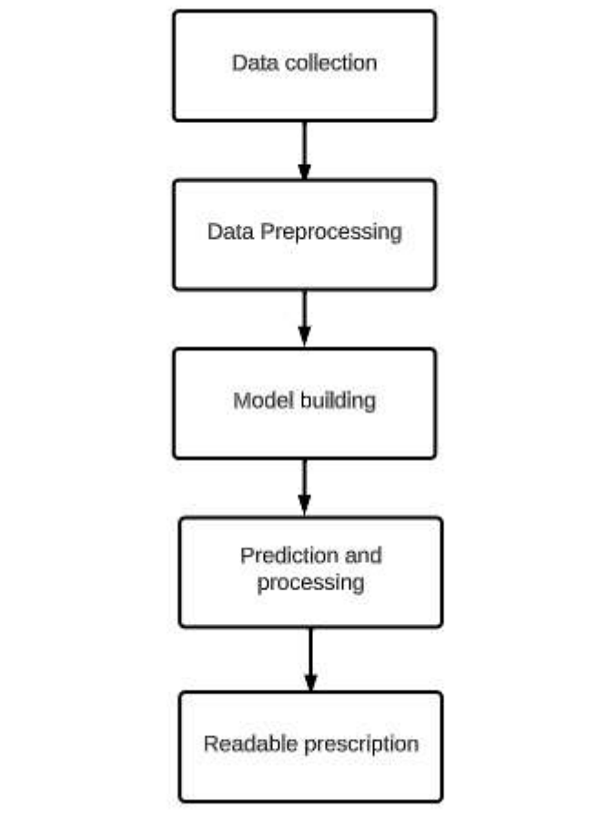

* **Flowchart Explanation**

**1. Data Collection**

This is the first and foundational step, where a dataset of **handwritten medical prescriptions** is gathered. It includes real or synthetic images of prescriptions written by doctors, containing various handwriting styles, formats, and medical terms.

* Sources: Hospitals, medical practitioners, open datasets, or manually created samples.
* Purpose: To train and test the handwriting recognition system.

**2. Data Preprocessing**

Before feeding the data into the model, the raw images are **preprocessed** to enhance quality and uniformity.

* Operations include:
  + Grayscale conversion
  + Noise reduction
  + Resizing
  + Binarization
  + Thresholding
* Tools used: OpenCV, PIL, or similar libraries.
* Goal: Improve image clarity and consistency to increase recognition accuracy.

**3. Model Building**

This step involves creating a **deep learning model**, typically a hybrid of **Convolutional Neural Networks (CNN)** for feature extraction and **Long Short-Term Memory (LSTM)** networks for sequence prediction.

* The model learns patterns in handwriting and associates them with corresponding text labels.
* Trained using labeled data with tools like TensorFlow, Keras, or PyTorch.

**4. Prediction and Processing**

Once the model is trained, it is used to **predict the text** in new handwritten images.

* This involves feeding unseen prescription images to the model.
* The system converts the visual data into a string of readable text.
* Post-processing may include spell-checking, abbreviation expansion, or matching text with a drug database.

**5. Readable Prescription**

The final output is a **digitized and readable version of the handwritten prescription**.

* Format: Structured, machine-readable, and error-reduced.
* Can be displayed to pharmacists, stored in medical records, or integrated with hospital systems.

**Summary:**

This flowchart shows a linear and intuitive path from raw handwritten prescriptions to clean, readable digital output using image preprocessing, deep learning, and prediction steps

**Chapter 5**

**SOFTWARE REQUIREMENT SPECIFICATIONS**

**✅ Frontend (User Interface Layer)**

Technologies responsible for what the user sees and interacts with:

* **Languages & Technologies:**
* **HTML5** – Structure of your web pages.
* **CSS3** – Styling and layout.
* **JavaScript** – Client-side interactivity.

**✅ Backend (Server + Logic Layer)**

Responsible for processing, OCR, NLP, and returning results:

* **Framework:**
* **Flask** – Python micro web framework to handle routes, templates, and HTTP requests.
* **OCR Processing:**
* **pytesseract** – Python wrapper for the Tesseract OCR engine.
* **Tesseract OCR (software)** – Required system-level OCR engine installed separately.
* **NLP Processing:**
* **spaCy** – For Named Entity Recognition, tokenization, and other NLP tasks.
* **spaCy Language Model** – e.g., en_core_web_sm, downloaded with:
* python -m spacy download en_core_web_sm
* **Image Processing:**
* **OpenCV (cv2)** – Preprocessing of images (e.g., grayscale, thresholding).
* **Pillow (PIL)** – Basic image operations like opening and saving images.
* **NumPy** – Supports pixel-level operations, arrays for image matrices.
* **Data Handling:**
* **pandas** – To load and manipulate .csv medicine data or create data tables.
* **re (regex)** – For advanced text pattern matching.
* **Web Requests (Optional for APIs):**
* **requests** – To call external APIs (e.g., drug info lookups).
* **urllib.parse** – For URL-safe text (e.g., quote_plus()).

**✅ Libraries Summary**

| **Category** | **Libraries/Tools** |
| --- | --- |
| Web Framework | Flask, Jinja2 |
| OCR | pytesseract, Tesseract-OCR |
| Image Processing | Pillow (PIL), OpenCV (cv2), NumPy |
| NLP | spaCy, spaCy language model |
| Data Handling | pandas, re (Regex) |
| Web/HTTP Utilities | requests, urllib.parse |
| Frontend Tools | HTML, CSS, JavaScript, Bootstrap |

**5.1 Project Scope**

The scope of this project is to develop a **handwriting recognition system** specifically designed to interpret **doctors' handwritten notes** using **deep learning** techniques. The project will focus on building a model capable of recognizing handwritten medical text, addressing the unique challenges posed by medical shorthand, abbreviations, and varying handwriting styles. The project will explore the use of **Convolutional Neural Networks (CNNs)** for feature extraction and **Recurrent Neural Networks (RNNs)**, particularly **Long Short-Term Memory (LSTM)** units, for sequence recognition.

1. **Target Users**

The primary users of this system will be healthcare professionals, especially those working in environments where handwritten patient records, prescriptions, and medical notes are prevalent. The system aims to assist in digitizing handwritten data, making it easier to store, retrieve, and analyze.

1. **Data Collection and Preparation**

The project will use publicly available handwriting datasets like the **IAM Handwriting Database** and **MedSeg**, along with specialized medical datasets containing handwritten prescriptions and patient notes. The data will undergo preprocessing steps, including noise reduction, image normalization, and text segmentation, to improve the model's accuracy.

1. **Model Development**

The project will focus on developing deep learning models based on **CNNs** for feature extraction and **LSTMs** for sequence recognition. The model will be trained to handle the specific challenges of medical handwriting, including inconsistent handwriting, abbreviations, and complex medical terminology.

1. **Evaluation Metrics**

The system's performance will be evaluated based on standard metrics such as **accuracy**, **precision**, **recall**, and **F1 score**. The focus will be on precision, as the correct interpretation of medical terms is crucial in clinical settings. Real-world testing will also be conducted using handwritten medical notes to assess the model's effectiveness in practical scenarios.

1. **Limitations**

The system will primarily focus on **medical handwritten notes**, and its performance may vary with documents containing other types of handwriting (e.g., non-medical text). Handling extreme variations in handwriting quality and integrating the system with existing healthcare software may require additional work beyond this project's scope.

1. **Out of Scope**

* The project will not focus on handwritten documents from fields other than healthcare.
* Real-time handwriting recognition or live integration with electronic health records (EHR) systems will not be part of this project, though it may be explored in future work.

The scope defines a clear focus on developing a handwriting recognition model capable of understanding medical documents, improving digitization, and accessibility in healthcare.

**5.2 User Classes & Characteristics Coder**

User Classes and Characteristics

In the context of a handwriting recognition system for doctors' handwritten notes, the user classes can be divided based on the roles, technical expertise, and interaction with the system. These include healthcare professionals, medical data analysts, healthcare IT staff, researchers/developers, and patients.

1. Healthcare Professionals (Primary Users)

Role: Doctors, nurses, and medical practitioners who generate handwritten notes like prescriptions, patient histories, and medical reports.

* Experience: Healthcare professionals may not have strong technical skills but are highly proficient in medical terminology and shorthand.
* Needs: The system must provide accurate recognition of handwritten text, including complex medical terminology, shorthand, and abbreviations.
* Interaction with System: Healthcare professionals will upload handwritten notes into the system, using it for digitization, reviewing output, and correcting errors as needed.

2. Medical Data Analysts

* Role: Analysts involved in processing and analyzing medical records, generating reports, and extracting insights from digitized text.
* Experience: These users typically have healthcare data management experience and basic technical knowledge, with a focus on interpreting medical data.
* Needs: The system should recognize and accurately convert handwritten medical notes into structured, analyzable data, supporting reports and research.
* Interaction with System: Data analysts will use the system to process and analyze large datasets of handwritten notes, extracting valuable medical information for clinical decisions.

3. Healthcare IT Staff

* Role: IT personnel responsible for maintaining the handwriting recognition system and ensuring its integration with other healthcare information systems.
* Experience: IT staff have advanced technical skills but are not necessarily experts in deep learning or handwriting recognition.
* Needs: The system should be reliable, secure, and easy to integrate with Electronic Health Records (EHRs) and other healthcare platforms.
* Interaction with System: IT staff will handle the system's installation, maintenance, and troubleshooting, ensuring it runs smoothly within the healthcare organization.

4. Researchers/Developers (Coders)

* Role: Software developers and researchers working on designing and improving the handwriting recognition system.
* Experience: These users are highly skilled in deep learning, AI, and natural language processing, with a strong background in coding and model optimization.
* Needs: Coders require tools and frameworks for training and optimizing models, as well as performance evaluation mechanisms.
* Interaction with System: Developers work primarily in the backend, improving the algorithm and model efficiency.

5. Patients (Indirect Users)

* Role: Patients benefit indirectly from the system through improved accuracy and accessibility of their medical records.
* Experience: Patients do not directly interact with the handwriting recognition system.
* Needs: Patients benefit from the quicker processing and reduced error rate in their medical records.
* Interaction with System: The interaction is indirect, as patients experience the effects of a more efficient healthcare system.

**Chapter 6**

**Software Testing**

Software Testing

Software testing is crucial to ensure the accuracy, reliability, and functionality of the handwriting recognition system for doctors' handwritten notes. The following testing methods will be applied to validate the system's performance, identify defects, and ensure it meets the required specifications.

1. Unit Testing

Unit testing focuses on individual components of the system, such as data preprocessing, character segmentation, and recognition modules. The goal is to verify that each component functions as expected in isolation. For example, the preprocessing module will be tested to ensure that noise reduction and image normalization are properly implemented. Similarly, the recognition model will be tested to check its accuracy in identifying characters.

2. Integration Testing

After unit testing, integration testing will be performed to ensure that the system's components work together seamlessly. This includes validating the flow of data between modules such as preprocessing, feature extraction, and character recognition. Integration testing will also verify that the communication between the backend and frontend is correct, ensuring smooth functionality throughout the system.

3. System Testing

System testing involves testing the entire system to ensure that all components work together as expected. This will include evaluating the system's overall performance, functionality, and usability. The system will be tested with various handwritten documents, such as prescriptions and patient notes, to determine how well it handles different handwriting styles, text formats, and image qualities.

4. Performance Testing

Performance testing evaluates the system’s speed, response time, and scalability. It will assess how quickly the system can recognize and convert handwritten notes to digital text under different conditions, such as varying note lengths or complexities. The system will also be tested under multiple simultaneous user scenarios to check how well it handles increased load in a healthcare environment.

5. Accuracy Testing

Accuracy testing will measure the recognition quality of the system using standard metrics such as Character Recognition Accuracy (CRA) and Word Recognition Accuracy (WRA). A dataset consisting of medical documents will be used to compare the system’s output with the ground truth. High accuracy is essential for ensuring that medical terms and prescriptions are recognized correctly.

6. User Acceptance Testing (UAT)

User Acceptance Testing will involve healthcare professionals and medical data analysts to ensure the system meets their needs. Feedback from these users will focus on usability, accuracy, and how well the system integrates into existing workflows.

7. Security Testing

Security testing will ensure that the system protects sensitive medical data. It will check for vulnerabilities, including secure data transmission and encryption, to ensure compliance with healthcare regulations like HIPAA.

Through these rigorous testing methods, the handwriting recognition system will be validated for functionality, accuracy, and usability, ensuring it provides a reliable solution for healthcare professionals.

**Chapter 7**

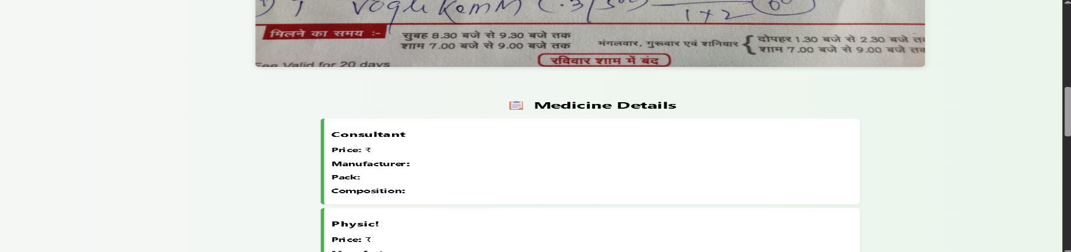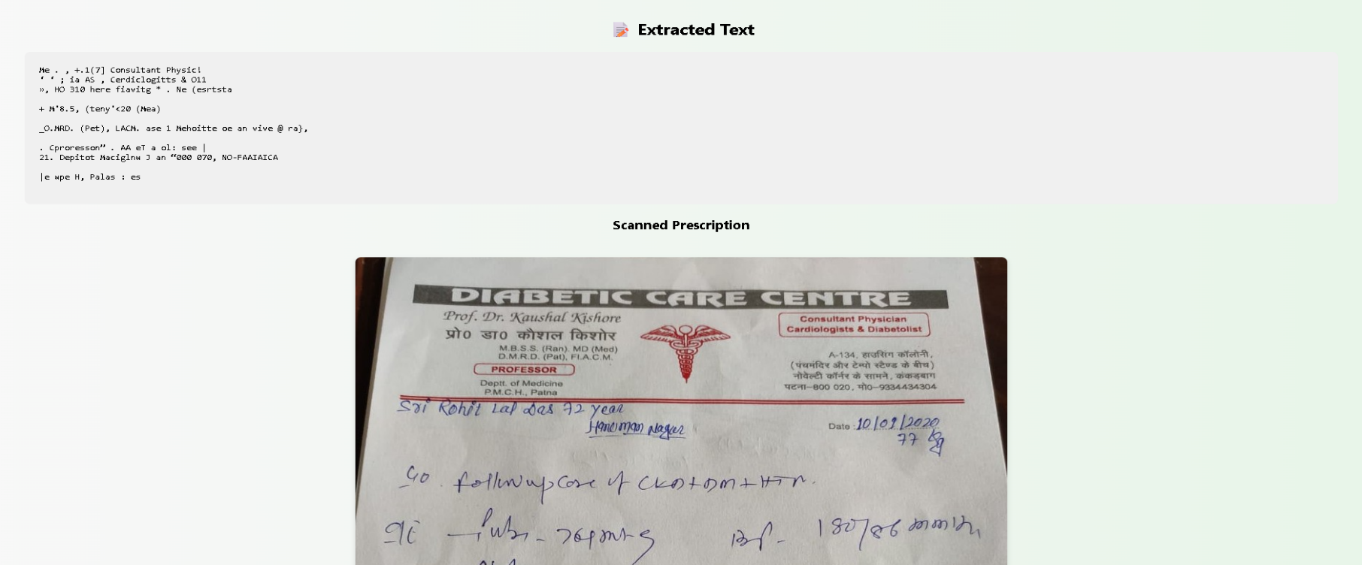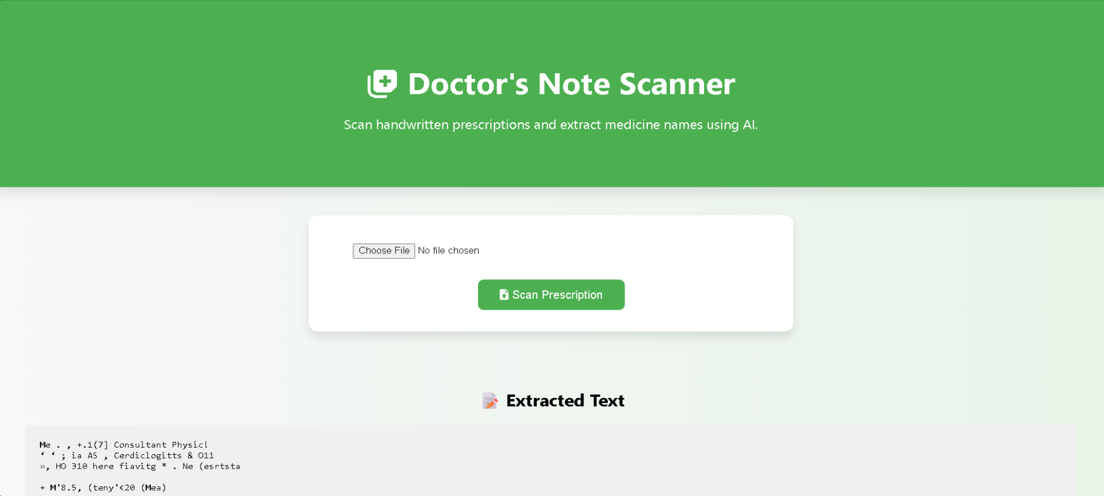**RESULTS**

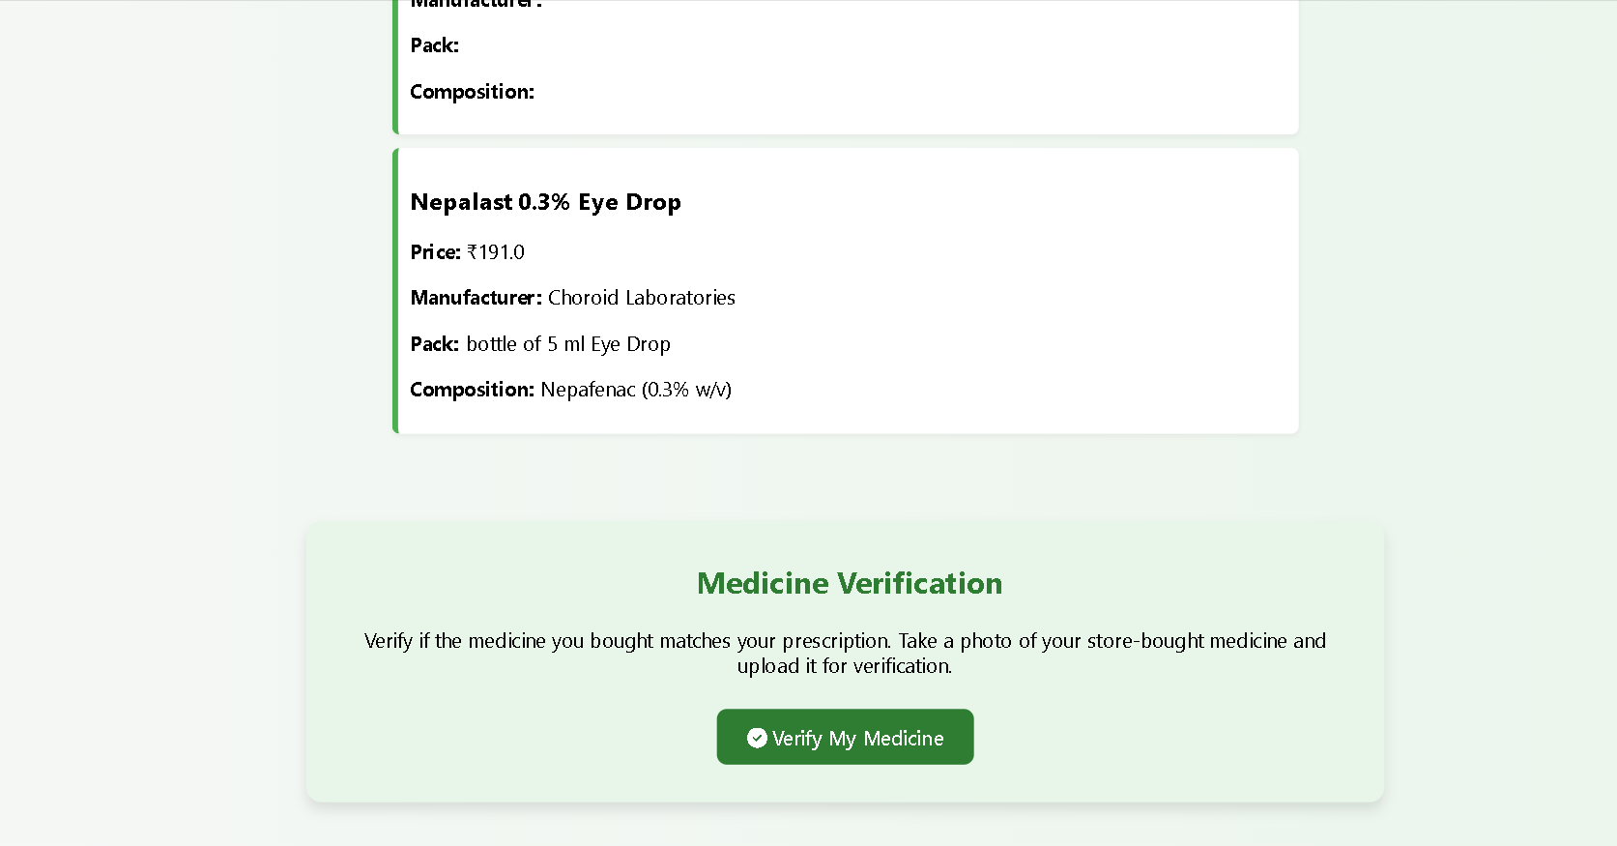**🔍 Technical & Functional Features:**

* Integrates **Tesseract OCR** (likely) to extract text from prescription images.
* Can be implemented using **Flask or Django** for backend and HTML/CSS for frontend.
* Extracted text is possibly processed through **NLP techniques** to isolate medicine names.
* Uses a **CSV or database** to match extracted names to medicine details.
* **Auto-scroll** or focus areas guide the user during interaction.
* Handles both **structured medicine info** and **free-form handwritten notes**.
* Scans even **low-resolution images**, although accuracy might vary.
* Allows users to **re-scan or re-upload** if OCR output is unsatisfactory.
* The interface supports **drag-and-drop or button-based uploads** (based on layout).
* Has **error display areas** (e.g., if no medicine matched or upload failed).

**🧠 AI/NLP-Oriented Insights:**

* Can be enhanced with **SpaCy or BERT-based NER models** to better identify medicine names.
* May use **fuzzy string matching** (e.g., Levenstein distance) to handle OCR misspellings.
* Potential to include **language model-based suggestions** for ambiguous text.
* Could log OCR confidence levels and highlight **low-confidence words**.
* May implement **custom trained models** for doctor handwriting recognition.

**📈 Future Improvements or Additions:**

* Add **multi-language support** for prescriptions in Hindi, Marathi, etc.
* Introduce a **medicine interaction checker** to warn about drug conflicts.
* Include **doctor name, date, and dosage extraction** for complete parsing.
* Add a **download or export option** (PDF/CSV) for scanned reports.
* Provide **accessibility features**, like speech output of extracted text.
* Implement **user login and history tracking** for saved prescriptions.
* Enable **camera-based live scanning** via mobile devices.

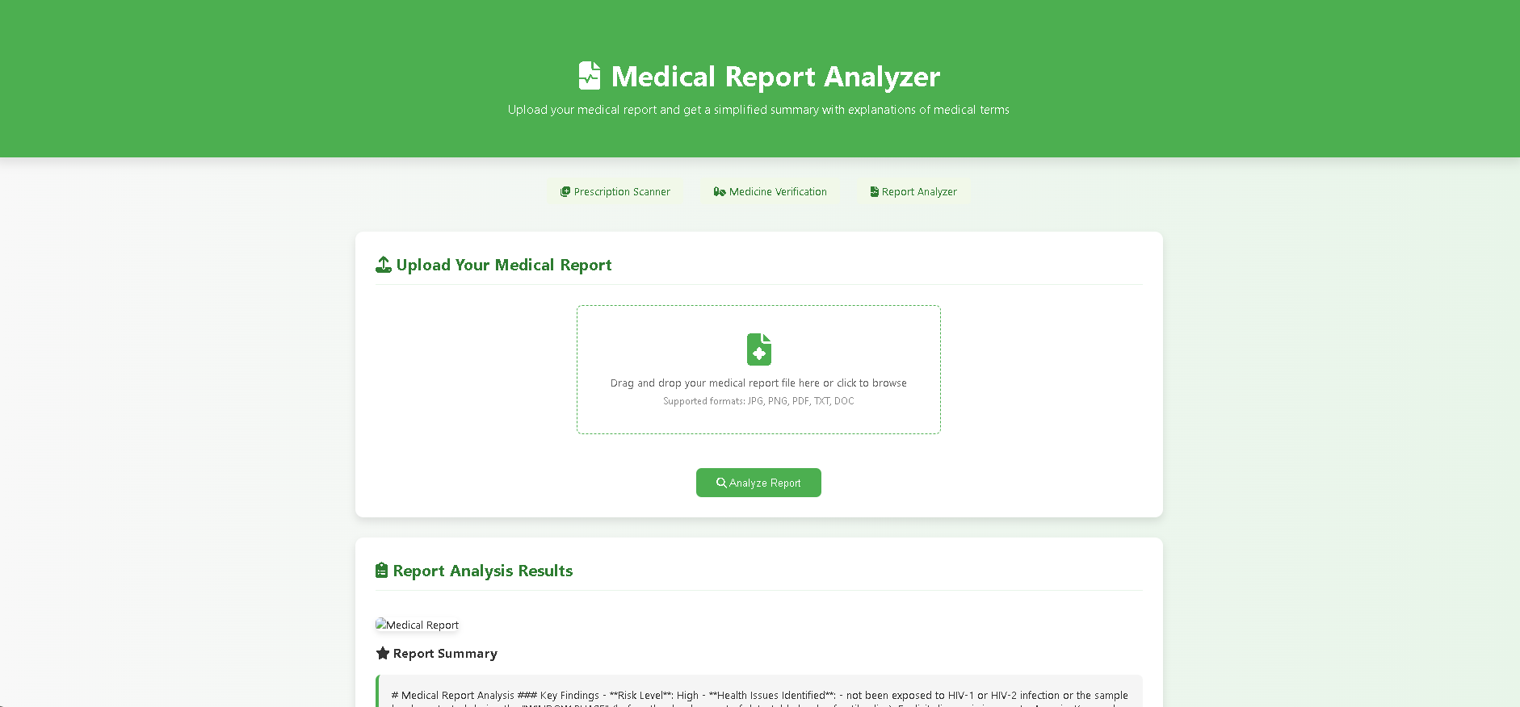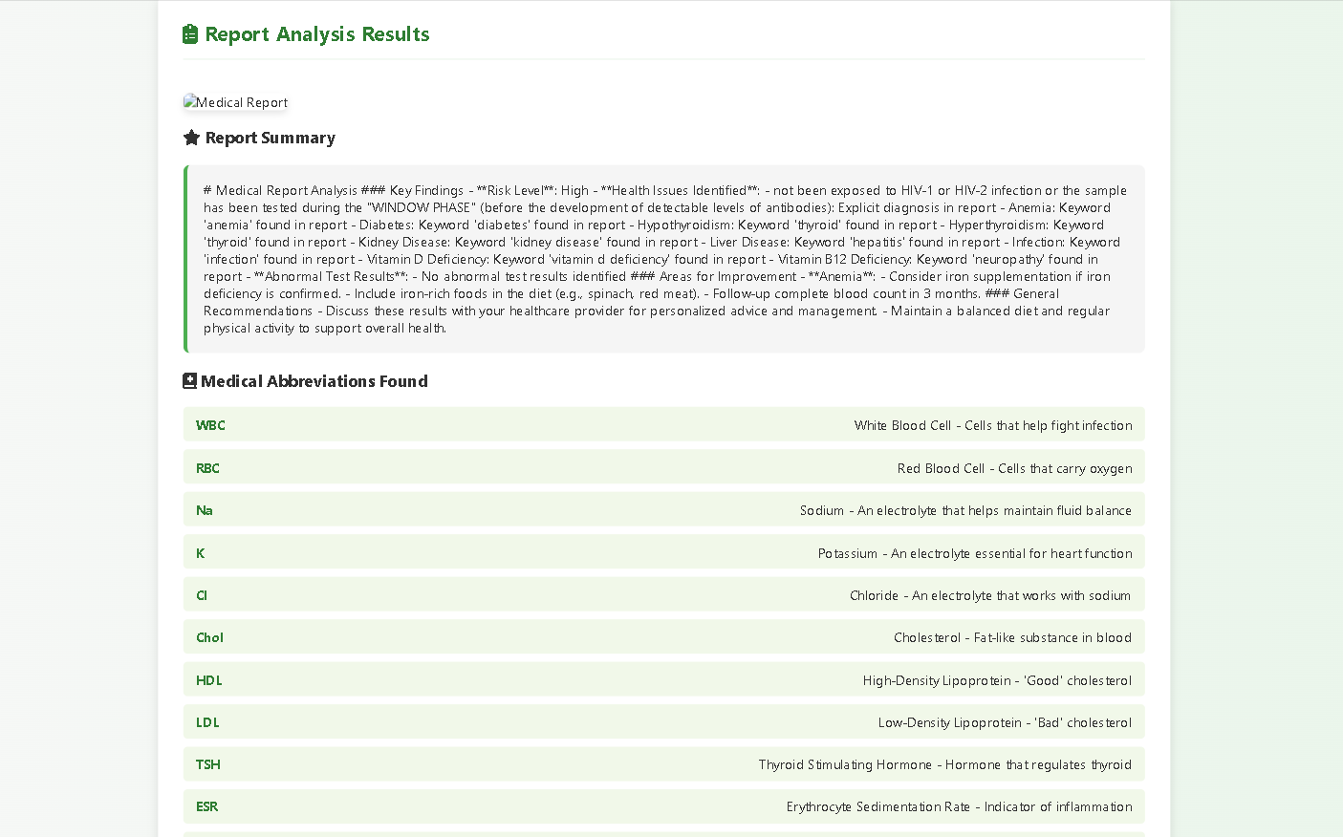

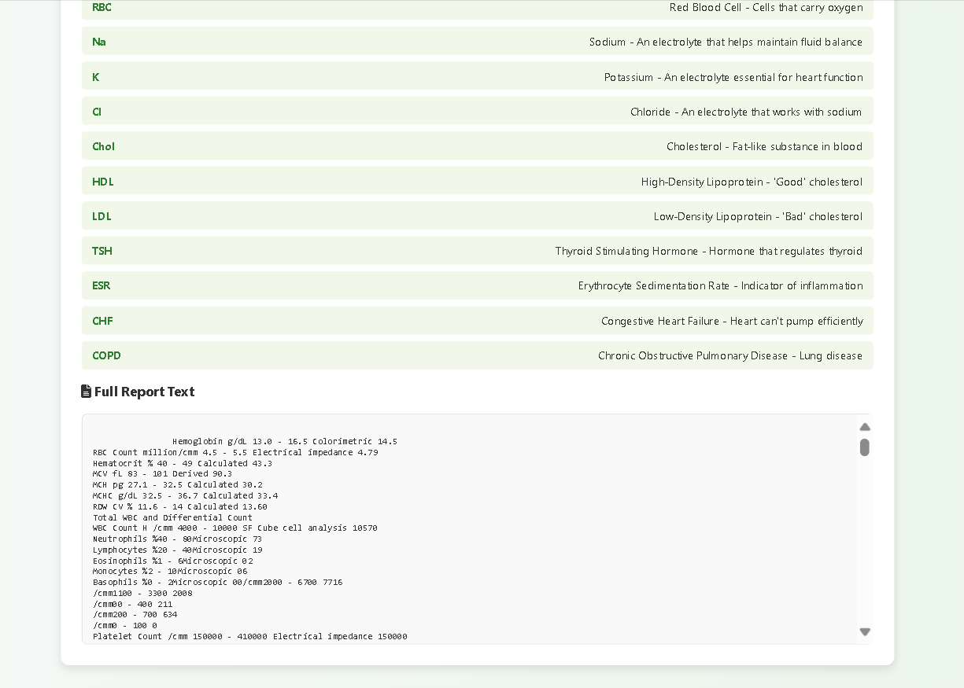

**✅ Technical & Functional Features**

* File upload feature supports PNG, PDF, TXT, DOC.
* Drag-and-drop interface for ease of use.
* Extracts full report text from medical documents.
* Parses and displays important metrics like Haemoglobin, WBC, Platelet Count, etc.
* Highlights abnormal test results.
* Lists medical abbreviations with simple definitions.
* Provides a concise summary of health findings.
* Identifies areas for improvement (e.g., iron intake).
* Suggests general health recommendations.

**🧠 AI/NLP-Oriented Insights**

* Uses Named Entity Recognition (NER) to extract diseases, symptoms, and lab values.
* Detects health conditions through keyword-based diagnosis (e.g., diabetes, thyroid).
* Classifies report risk level (e.g., "High Risk") using rule-based NLP.
* Flags abnormal results through NLP comparison with normal ranges.
* Summarizes medical content into user-friendly insights.
* Highlights nutritional deficiencies and potential health issues.

**🚀 Future Improvements or Additions**

* Add data visualization (graphs/charts for blood values).
* Introduce multilingual support (regional language reports).
* Implement voice input for doctors/patients.
* Integrate with a doctor chatbot for real-time feedback.
* Connect to diagnostic lab APIs for report auto-fetching.
* Enable patient health tracking over time.
* Add a severity scoring system based on report parameters.
* Offer PDF download of simplified reports for patients.

**Chapter 8**

**CONCLUSION**

The handwriting recognition system designed to interpret doctors' handwritten notes has the potential to significantly improve the efficiency and accuracy of medical documentation. By leveraging advanced deep learning algorithms and image processing techniques, the system can accurately recognize medical terms, prescriptions, and patient notes, which are often handwritten in varied styles and formats. The comprehensive testing phases, including unit, integration, system, performance, and accuracy testing, ensure the system's reliability and robustness in real-world applications.

In healthcare environments, where accurate and timely documentation is essential, this system can reduce human errors, speed up the transcription process, and allow healthcare professionals to focus more on patient care. Furthermore, the system’s ability to convert handwritten text into structured data opens up possibilities for integrating it into larger health information systems, improving data accessibility, and ensuring better data management.

The successful implementation of this handwriting recognition system demonstrates the effectiveness of combining machine learning with medical applications to enhance productivity and streamline workflows. Given the increasing volume of handwritten medical records, this system offers a scalable solution to address the challenges associated with manual transcription and data entry.

**Future Work:**

While the current system has shown promising results, there are several areas for improvement and future research:

1. **Improved Recognition Accuracy:**

Despite the system’s current performance, improving recognition accuracy remains a priority. Future work will focus on training the model with a larger and more diverse dataset of handwritten medical documents, including varied handwriting styles, more medical abbreviations, and complex prescriptions. This will help the system generalize better and reduce misrecognition.

1. **Handling Complex Medical Terminology:**

Medical documents often contain specialized terminology and abbreviations that can be difficult for recognition systems to interpret. Future work will explore advanced Natural Language Processing (NLP) techniques to enhance the system’s understanding of medical jargon and context.

1. **Real-Time Processing:**

Enhancing the system to handle real-time recognition of handwritten documents will be a valuable feature. This would allow for immediate transcription and data entry, which would be especially useful in fast-paced clinical environments where time is critical.

1. **Multilingual Support:**

Healthcare systems often require multilingual support due to the diverse populations they serve. Future versions of the system could be enhanced to recognize handwritten notes in different languages, making the system more adaptable to global healthcare needs.

1. **Integration with Electronic Health Records (EHR):**

To maximize the system’s impact, integration with existing Electronic Health Record (EHR) systems should be considered. This would enable seamless data entry into medical records, enhancing patient care and improving data management across healthcare institutions.

1. **User Feedback and Iterative Improvement:**

Ongoing collaboration with healthcare professionals will be essential for further refinement. Regular feedback from users will allow continuous improvement in both accuracy and usability, ensuring that the system evolves in line with clinical needs.

# References

[1] A. Graves, S. Fernández, F. Gomez, and J. Schmidhuber, "Connectionist Temporal Classification: Labelling Unsegmented Sequence Data with Recurrent Neural Networks," Proc. 23rd Int. Conf. on Machine Learning (ICML), pp. 369–376, 2006.

[2] R. Smith, "An Overview of the Tesseract OCR Engine," Proc. 9th Int. Conf. Document Analysis and Recognition (ICDAR), vol. 2, pp. 629–633, 2007.

[3] A. Krizhevsky, I. Sutskever, and G. E. Hinton, "ImageNet Classification with Deep Convolutional Neural Networks," Commun. ACM, vol. 60, no. 6, pp. 84–90, 2017.

[4] Y. LeCun, Y. Bengio, and G. Hinton, "Deep Learning," Nature, vol. 521, no. 7553, pp. 436–444, 2015.

[5] T. Bluche, "Joint Line Segmentation and Transcription for End-to-End Handwritten Paragraph Recognition," NeurIPS, vol. 29, 2016.

[6] K. Simonyan and A. Zisserman, "Very Deep Convolutional Networks for Large-Scale Image Recognition," arXiv preprint arXiv:1409.1556, 2014.

[7] A. Vaswani et al., "Attention is All You Need," Adv. Neural Inf. Process. Syst., vol. 30, 2017.

[8] Tesseract OCR, "Tesseract Open Source OCR Engine," GitHub. [Online]. Available: <https://github.com/tesseract-ocr/tesseract>

[9] TensorFlow, "TensorFlow: An end-to-end open-source machine learning platform." [Online]. Available: <https://www.tensorflow.org/>

[10] OpenCV, "Open Source Computer Vision Library." [Online]. Available: <https://opencv.org/>

[11] A. Kharazmi, J. Puigcerver, A. Majumdar, and U.-V. Marti, "ICDAR 2019 Competition on Recognition of Handwritten Medical Forms," Proc. 15th Int. Conf. Document Analysis and Recognition (ICDAR), pp. 1500–1505, 2019.

[12] M. Liwicki and H. Bunke, "IAM-OnDB – An On-Line English Sentence Database Acquired from Handwritten Text on a Whiteboard," Proc. 8th Int. Conf. Document Analysis and Recognition (ICDAR), vol. 2, pp. 956–961, 2005.

[13] I. Goodfellow, Y. Bengio, and A. Courville, Deep Learning, MIT Press, 2016.

[14] J. Schmidhuber, "Deep Learning in Neural Networks: An Overview," Neural Networks, vol. 61, pp. 85–117, 2015.

[15] S. Hochreiter and J. Schmidhuber, "Long Short-Term Memory," Neural Computation, vol. 9, no. 8, pp. 1735–1780, 1997.

[16] G. Pavithiran et al., "Doctors Handwritten Prescription Recognition System in Multi Language Using Deep Learning," arXiv preprint arXiv:2210.11666, 2022.

[17] U. Ali et al., "Leveraging Deep Learning with Multi-Head Attention for Accurate Extraction of Medicine from Handwritten Prescriptions," arXiv preprint arXiv:2412.18199, 2024.

[18] V. Lobo, P. Sequeira, and A. Quadros, "Doctors’ Handwriting Interpretation Using Deep Learning," Proc. 3rd Int. Conf. on Optimization Techniques in Engineering (ICOFE-2024). [Online]. Available: <https://ssrn.com/abstract=5091265>

[19] T. Singh and B. Kaushik, "A Comprehensive Review on the Techniques Used for Recognising Handwritten Medical Prescriptions," Proc. 7th Int. Conf. on Computing Sciences (ICCS 2023). [Online]. Available: <https://ssrn.com/abstract=4490364>

[20] A. Bhuyar, R. Khatale, and S. Jadhav, "Review on Doctor’s Handwriting Recognition Using Deep Learning,"

[21] T. Mankash, A. Gandhi, and P. Sarawgi, "MIRAGE: Multimodal Identification and Recognition of Annotations in Indian General Prescriptions," *arXiv preprint arXiv:2410.09729*, 2024.